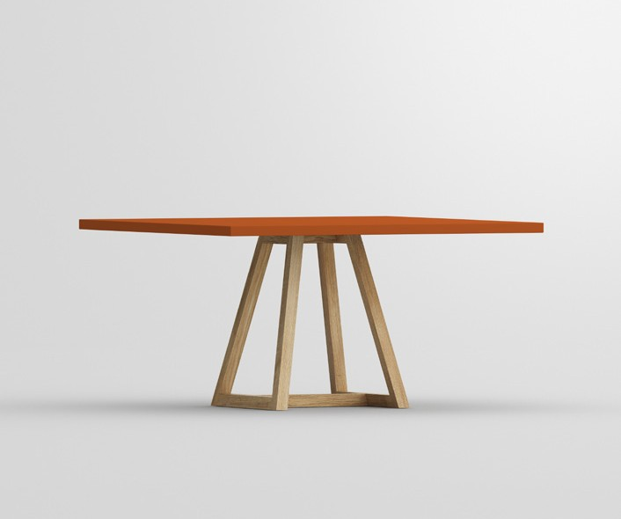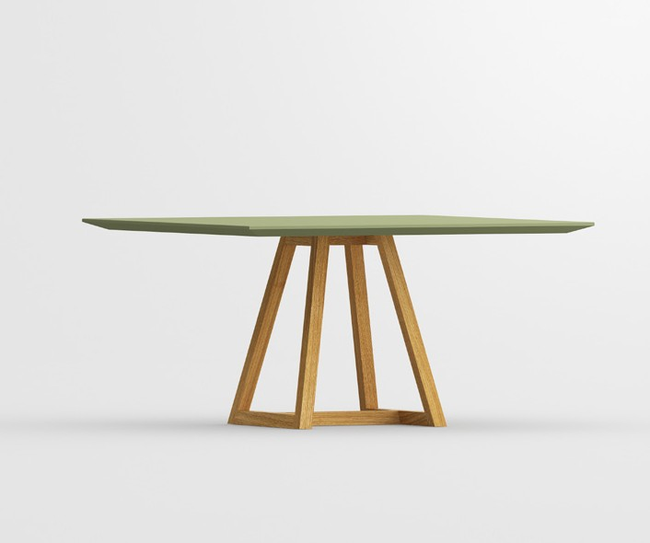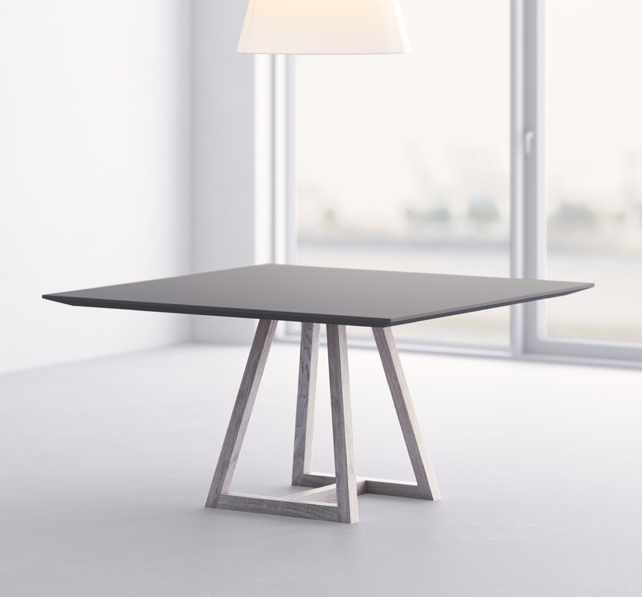

PRESS RELEASE

**German Innovation Award 2019 Winner, the third Design Award for**

**MARGO SQUARE LINO**

Table MARGO SQUARE LINO receives, after ICONIC AWARDS: Innovative In-

terior 2019 and Red Dot Award 2019, its third award with the German Innovation Award 2019

„Excellence in Business to Consumer > Interior & Living“

MARGO SQUARE LINO At first glance the graphic quality of the table‘s modern form appears.

The structural elements are defined by clarity of line. The design elements have been refined with a clear, minimalistic round or square table top made of solid wood or linoleum, completing the graphical expression. The edge profile is made by individual choice with straight or cham- fered edge.

For the second time, the winners of the German Innovation Awards were honoured at a gala

event held at the Museum of Technology in Berlin. More than 350 invited guests from industry, politics and the media attended the exclusive ceremony. The innovation competition is adminis- tered by the German Design Council, which was formed in 1953 as an initiative of the German Federal Parliament.

With the German Innovation Awards, the German Design Council pays tribute to forwardlooking

innovations with a long-term impact that offer added value for the user. There were 695 entries in total, including submissions from industry giants such as Samsung, Bosch, Deutsche Telekom and the Swiss group ABB, as well as hidden champions and start-ups.

“User-centred design is at the heart of our assess-

ment process for all the submitted innovations. This is the distinguishing feature of the German In- novations Awards,” explained Andrej Kupetz, CEO of the German Design Council. “And this is most successful when the future users are involved in the product and design development from an early stage. A lot of companies have realised this, and have adopted methods accordingly to ensure that they develop the best possible products.”



**VITA** - LIFE

**MIN** - MINIMALISM **VITAMIN** - HEALTH **DESIGN** - CREATION

vitamin design - nature friendly minimalistic design.

vitamin design was honored with the German Brand Award of the German Design Council

for outstanding brand management.

**About vitamin design**

vitamin design team designs and produces solid wood furniture with that certain so-

mething. gg designart, the company’s founder and designer, works very close with his team and has a long-standing experience and knowledge to develop a wide range of demanding solid wood furniture. Thanks to their up-to-date design the prospective classics from vitamin design are subtly presented based on ecological requirements and timeless modernity. Based on in-house and on close cooperation with selected manufacturers, vitamin design ensures

his high performance and quality standards. Therefore the focus lies on flexibility, clear design

and enhanced functionalities.

Press contact:

Gintaras Grabliauskas Dona Handelsges. mbH Grosse Elbstrasse 40

22767 Hamburg, Germany Phone: +49 (40) 31798362 [info@vitamin-design.com](mailto:info@vitamin-design.com) [www.vitamin-design.com/press](http://www.vitamin-design.com/press)

[www.vitamin-design.com](http://www.vitamin-design.com/)