**Fuo risalone 2019**

**PRESS RELEASE**

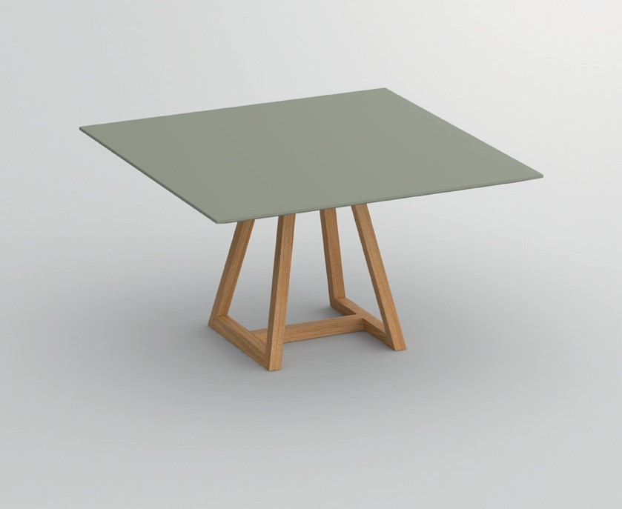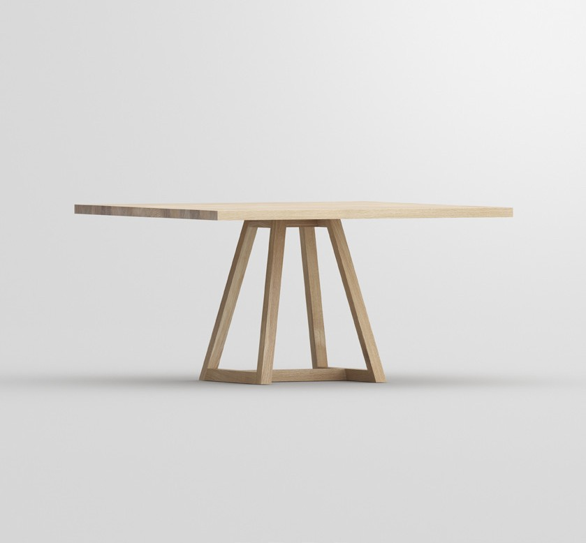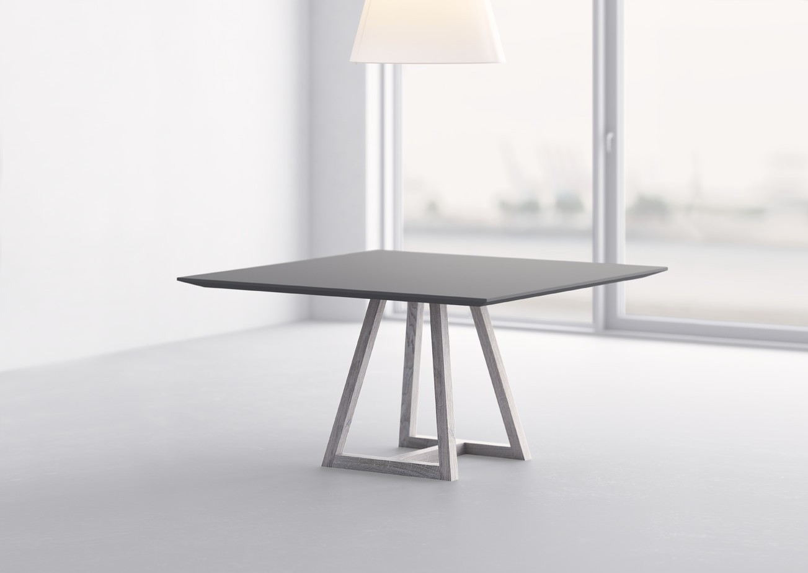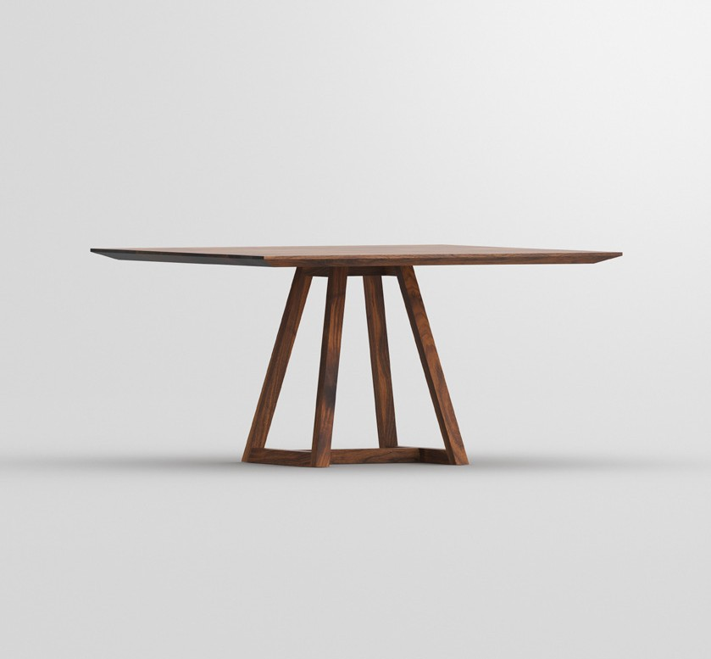

**Fuorisalone 2019**

PRESS RELEASE

**Table MARGO SQUARE LINO**

**Practical symbioses between solid wood and linoleum**

At first glance the graphic quality of the table‘s modern form appears.

The structural elements are defined by clarity of line. The diverse de- sign possibilities give a freedom choice in combining solid wood with linoleum. The edge profile can be chosen between straight

or slanted edge. Whether subtle or prominent design eve-

rything is possible completing the graphical expression.

The trend barometer of the interior design industry ICO-

NIC AWARDS: Innovative Interior honoured the table MARGO SQUARE LINO with the award “selection” in the category “interior”. The combination possibility creates individual design freedom for architects and property de- velopers. The German Design Council saw as well the dis- tinctive features and nominated the table for the German Innovation Award 2019. The innovation lies in the details with sustainable effect with the interplay of natural ma- terials and craftsmanship. Design quality is the common factor for award-winning products. MARGO SQUARE re- ceived the Red Dot Award: Product Design 2019, which the renowned jury only awards to products that feature an outstanding design.

Available in all linoleum and solid wood types from

vitamin design collection: European oak and knotted oak, ash, beech, core beech, American maple, walnut and cherry wood, treated with herbal oil.

Design: gg designart

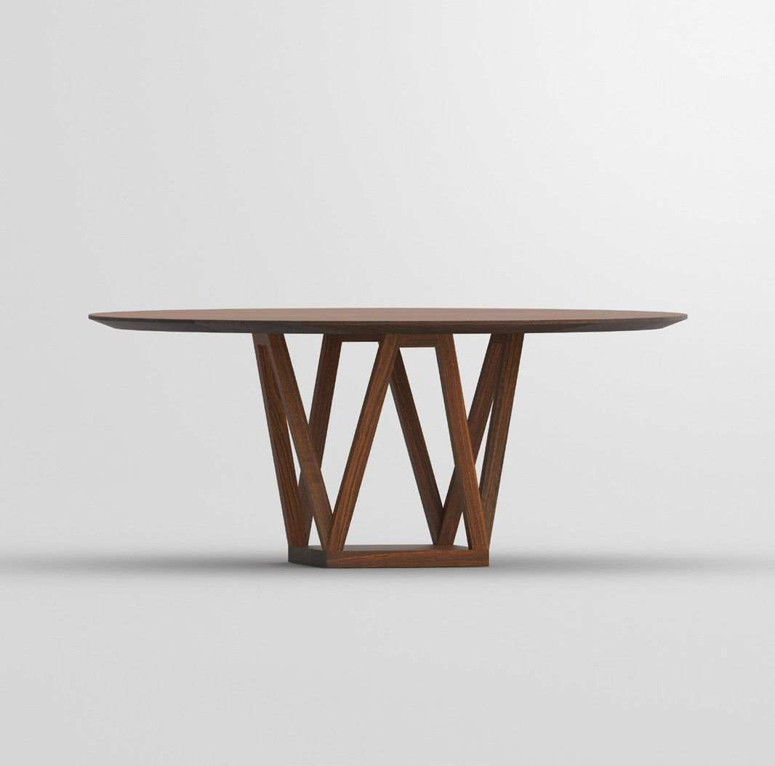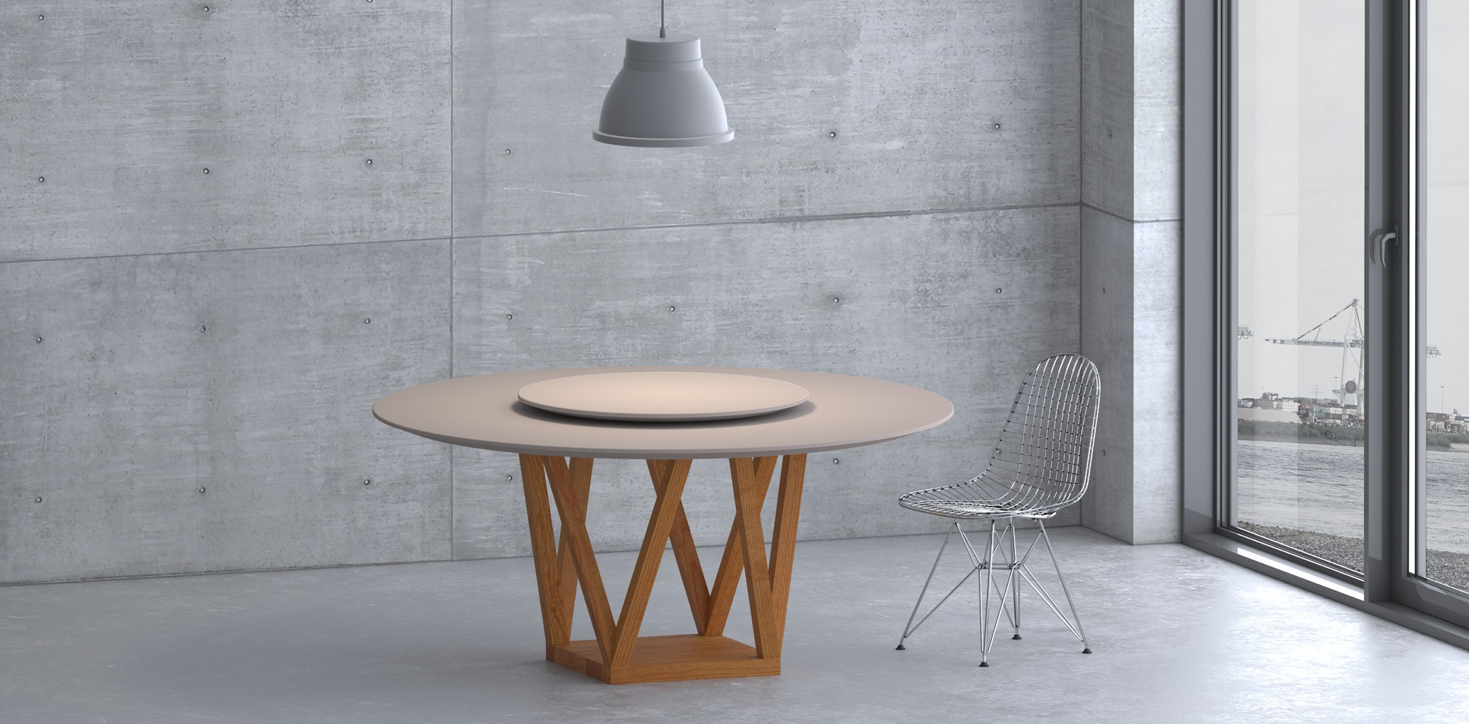

**Fuorisalone 2019**

PRESS RELEASE

**CREO**

**The unmistakable visual quality**

The round solid wood form has a warm appeal and is ideal for a great dining

experience with your family and friends. The central pillar with its trapezoid geometry is visually pleasing and offers lots of leg room. The clear lines con- vey elegance. On the 160 or 180 cm diameter solid wood table top is a Lazy Susan rotating tray with its decorative and

functional design.

The design concept convinced the experts

of the German Design Council for “German Design Award 2018: Winner” in the category “Excellent Product Design”

Statement of the jury: The distinctive cha- racteristic on the CREO table is its trapezo- id-shaped underframe which not only pro- vides plenty of leg room and stability, but

also lends the elegant table an unmistakable visual quality.

Available in all solid wood types from vit-

amin design collection: European oak and knotted oak, ash, beech, core beech, Ameri- can maple, walnut and cherry wood, treated with herbal oil.

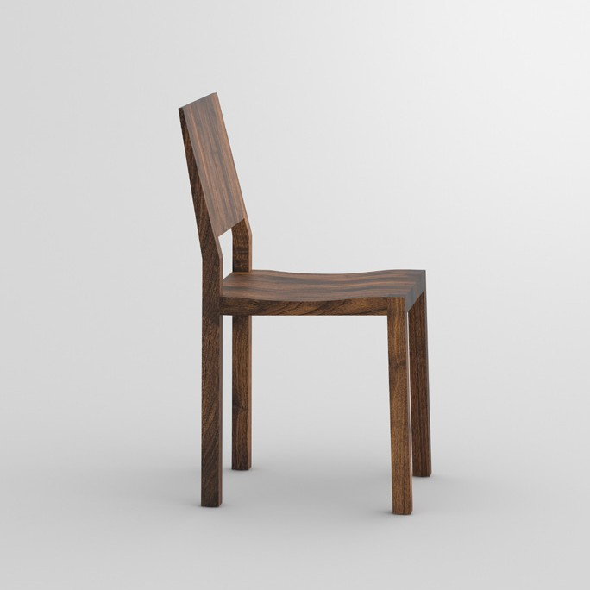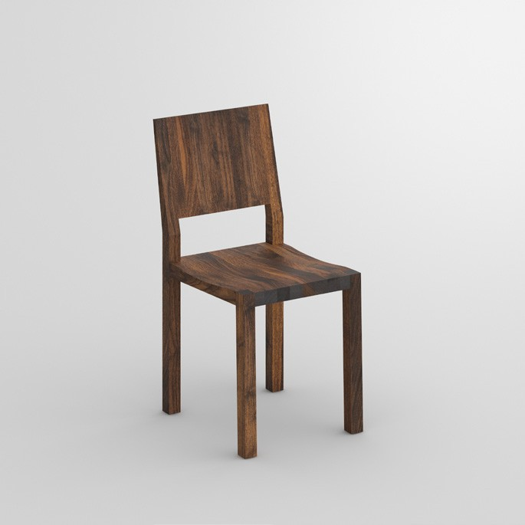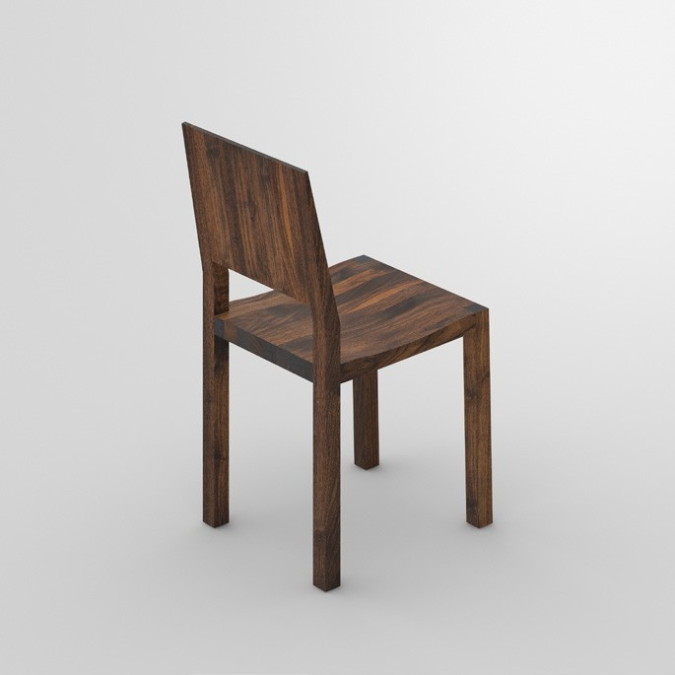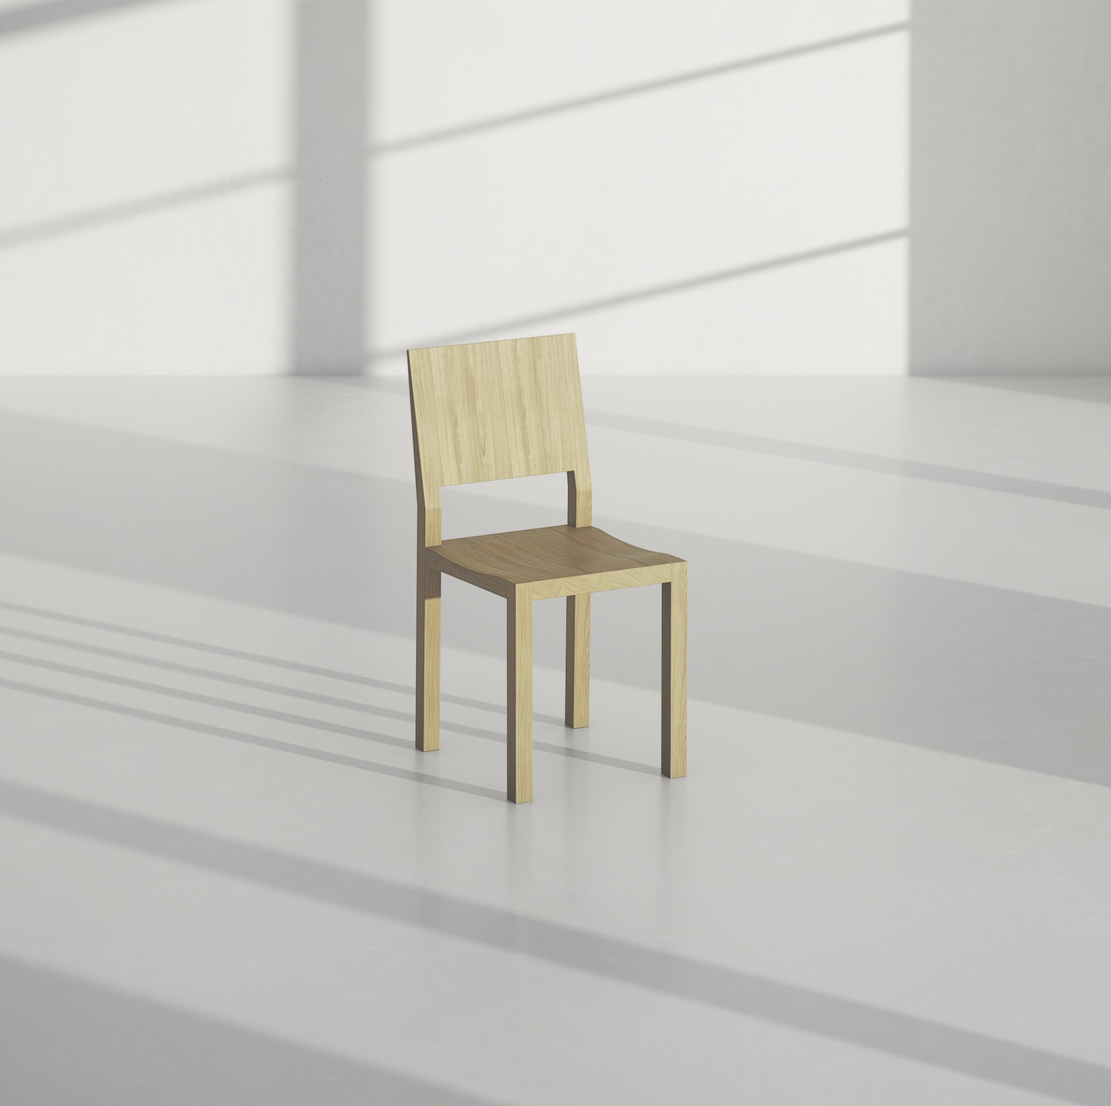

**Fuorisalone 2019**

PRESS RELEASE

**Chair TAU**

**Simple, minimalistic and unbelievably comfortable**

As one of the first models it stood the test of time, fitting perfectly into the design concept.

Chair TAU stands for fine simplicity and the ergonomics ma-

kes the sitting a pure delight. Seating accomodation embody- ing elegance and naturalness. Clear the stage for the natural craftsmanship!

Available in all solid wood types from vitamin design collec-

tion: European oak and knotted oak, ash, beech, core beech, American maple, walnut and cherry wood, treated with herbal oil.

Design: gg designart

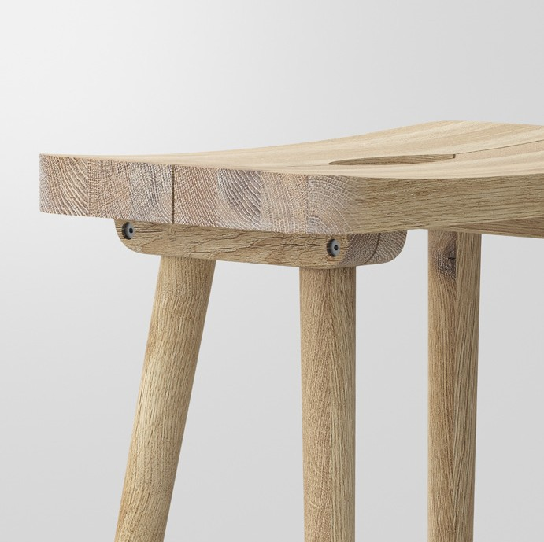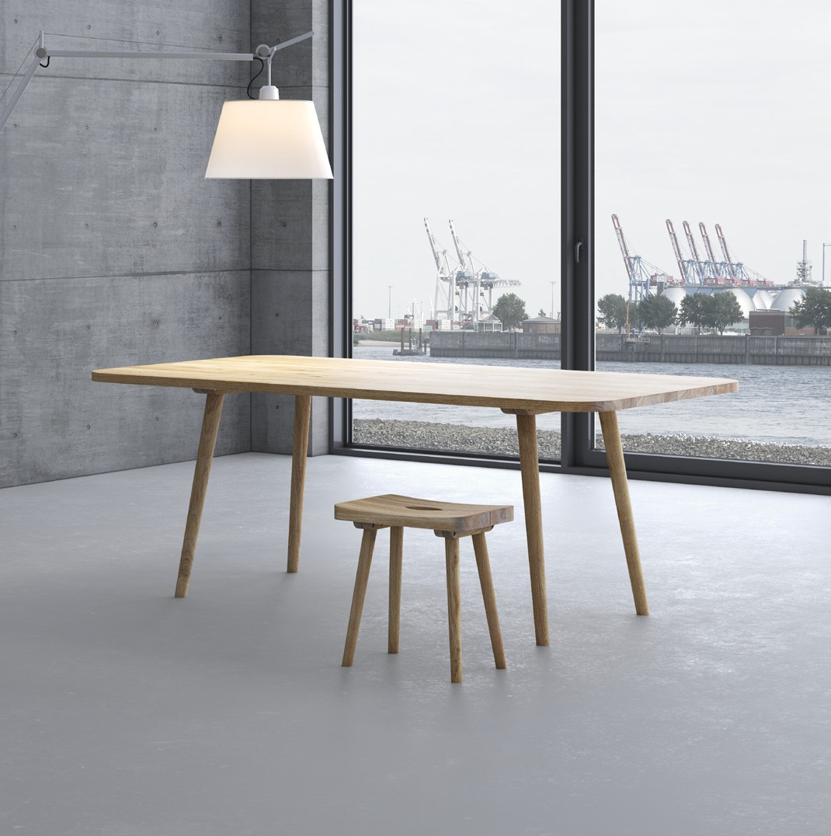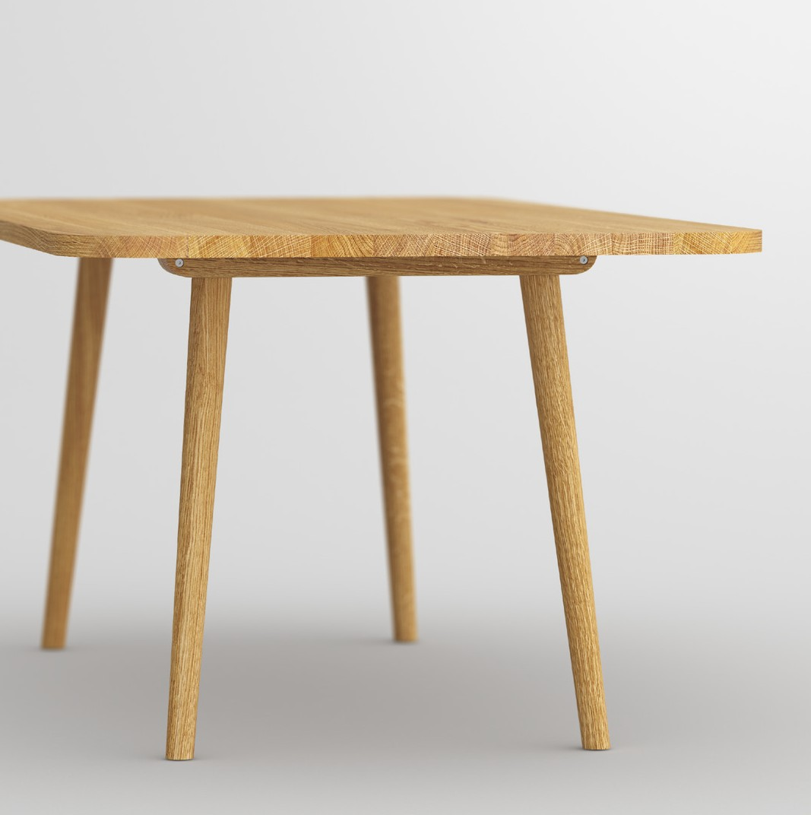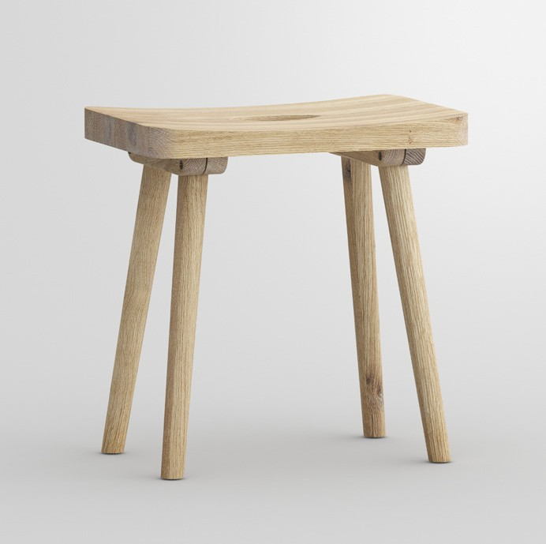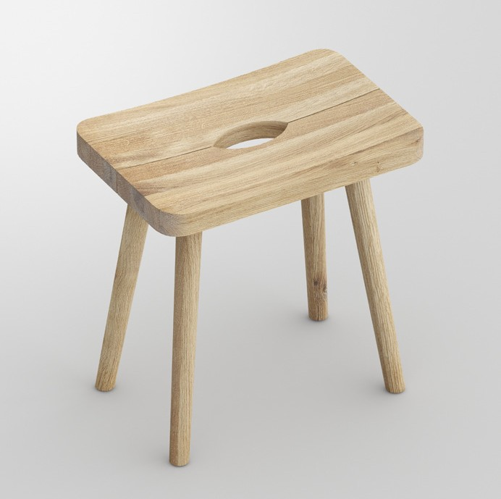

**Fuorisalone 2019**

PRESS RELEASE

**UNA**

**Antiquity, modern interpreted with craftsmanship**

The canny joint of the legs with the table frame serves as a striking design feature. The table

and the stool appear distinctively interesting and exclusive by adding the ergonomical shape. Since the ancient times the stool is basic equipment in houses. Makes everywhere a great impression as a practical accessory at home. Sometimes in the kitchen sometimes in the wardrobe with the grip opening the stool can be carried quickly and easily. Functional furnitu- re with charm. The natural grain of the wood enhances the easy going character for a perfect homely feeling.

Available in all solid wood types from vitamin design collection: European oak and knotted oak, ash, beech, core beech, American maple, walnut and cherry wood, treated with herbal oil.

Design: gg designart

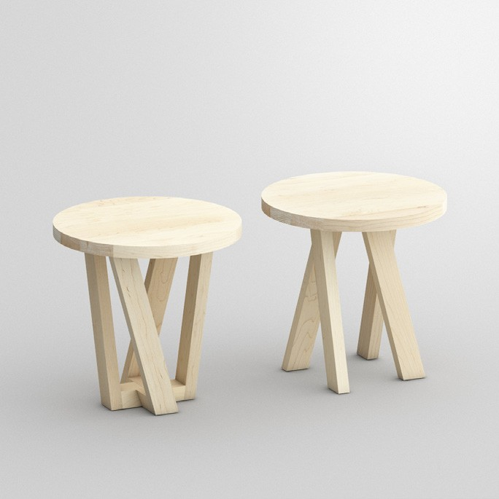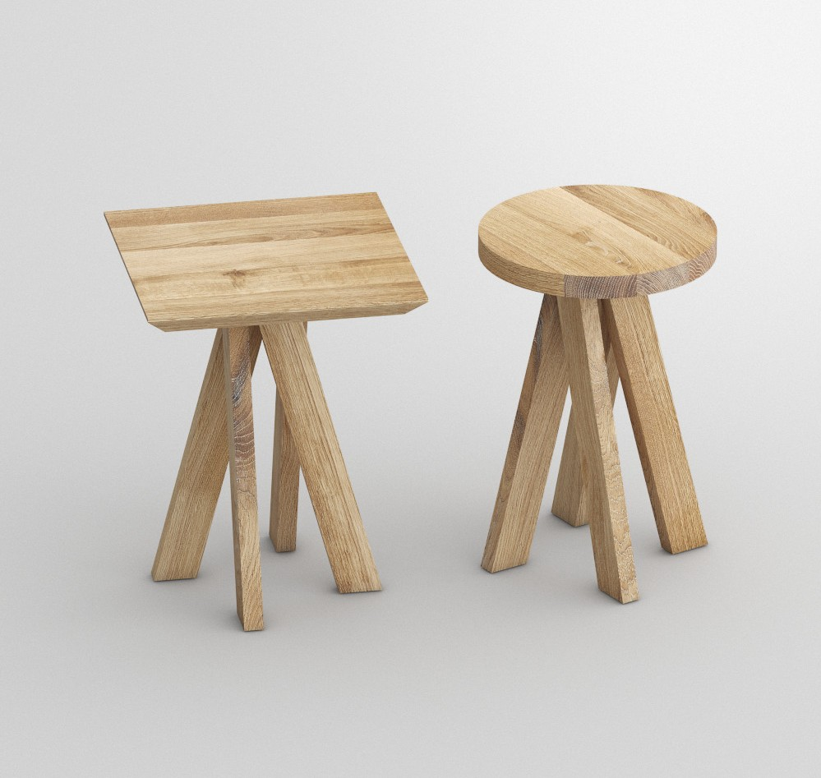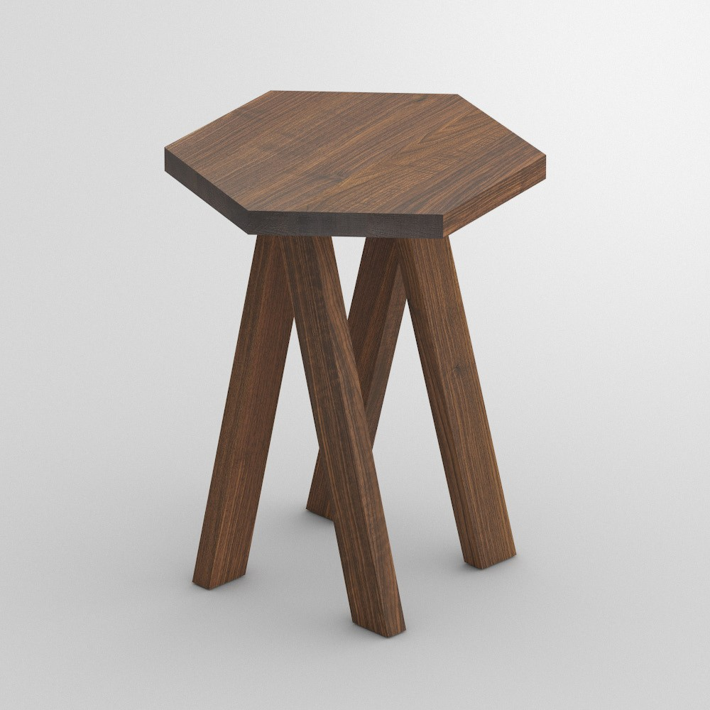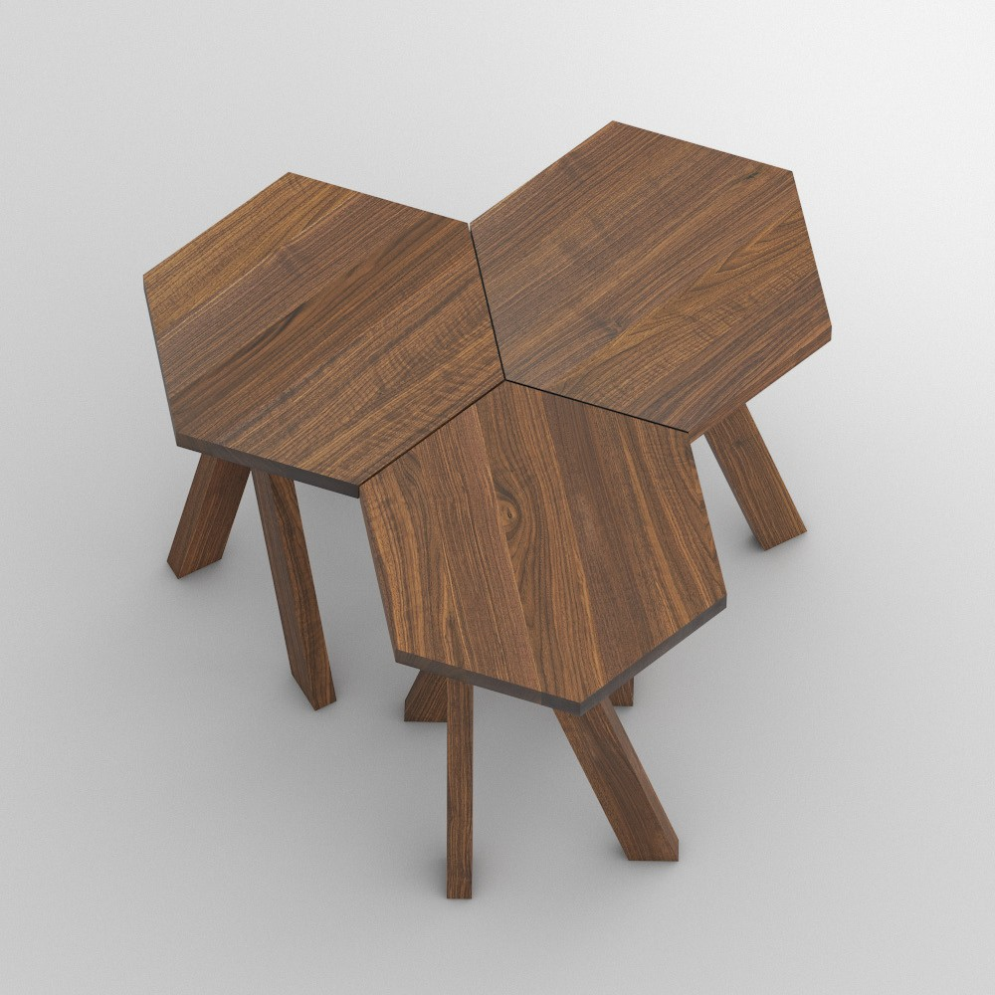

**Fuorisalone 2019**

PRESS RELEASE

**ZIRKEL**

**What goes around, comes around**

Table ZIRKEL doesn‘t beat around the bush, presenting its beautiful presence.

Sociable gathering with casual footwork running in circles around the tabletop. Always on the move conquering the catwalks with its excellent solid wood style. Combining great design in different shapes with natural sustainability. A true model: round or angular, ZIRKEL presents itself in almost every desired size.

Available in all solid wood types from

vitamin design collection: European oak and knotted oak, ash, beech, core beech, American maple, walnut and cherry wood, treated with herbal oil.

Design: gg designart



**GERMAN BRAND AWARD WINNER**

**VITA** - LIFE

**MIN** - MINIMALISM **VITAMIN** - HEALTH **DESIGN** - CREATION

vitamin design - nature friendly minimalistic design.

vitamin design was honored with the German Brand Award of the German

Design Council for outstanding brand management.

**Digital network with vitamin design**

The restructuring of all business units into digital processes is for every

company an important topic with a huge potential. We offer a solution to implement individual content management with innovation, functionality and data integration. The consumer has the liberty to get the desired infor- mation at anytime and anywhere. All products and information are just a click away.

**FUORISALONE 2019**

BASIC CELL

evolutive design exhibition

LOCATION:

SPAZIO S , via Olona 25, Milano (Santabrogio Design District)

PROJECT, CURATOR AND ORGANIZATION:

MAGDA DI SIENA STUDIO

[mds@magdadisiena.com www.magdadisiena.co](http://www.magdadisiena.co/)

Phone: +39 393 912 89 86

**About vitamin design**

vitamin design team designs and produces solid wood furniture with that certain

something. gg designart, the company’s founder and designer, works very close with his team and has a long-standing experience and knowledge to develop a wide range of de- manding solid wood furniture. Thanks to their up-to-date design the prospective classics from vitamin design are subtly presented based on ecological requirements and timeless modernity. Based on in-house and on close cooperation with selected manufacturers, vitamin design ensures his high performance and quality standards. Therefore the focus lies on flexibility, clear design and enhanced functionalities.

Press contact:

Gintaras Grabliauskas Dona Handelsges. mbH Grosse Elbstrasse 40

22767 Hamburg

Germany

+49 (40) 31798362

[info@vitamin-design.com](mailto:info@vitamin-design.com)

[www.vitamin-design.com](http://www.vitamin-design.com/)