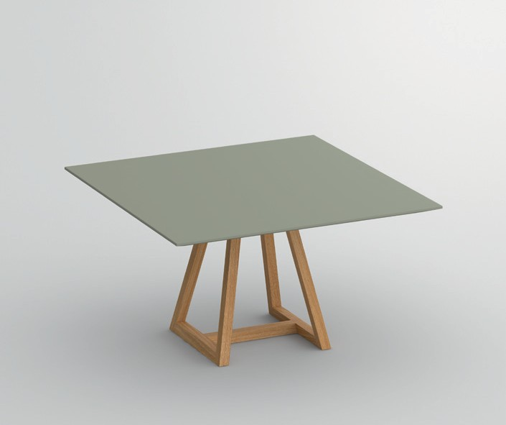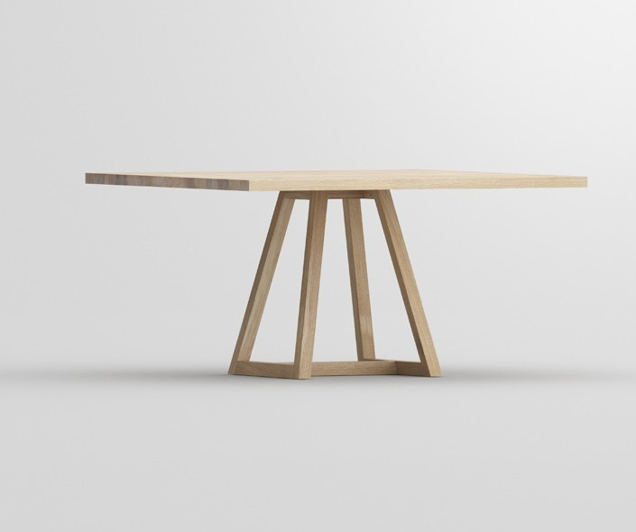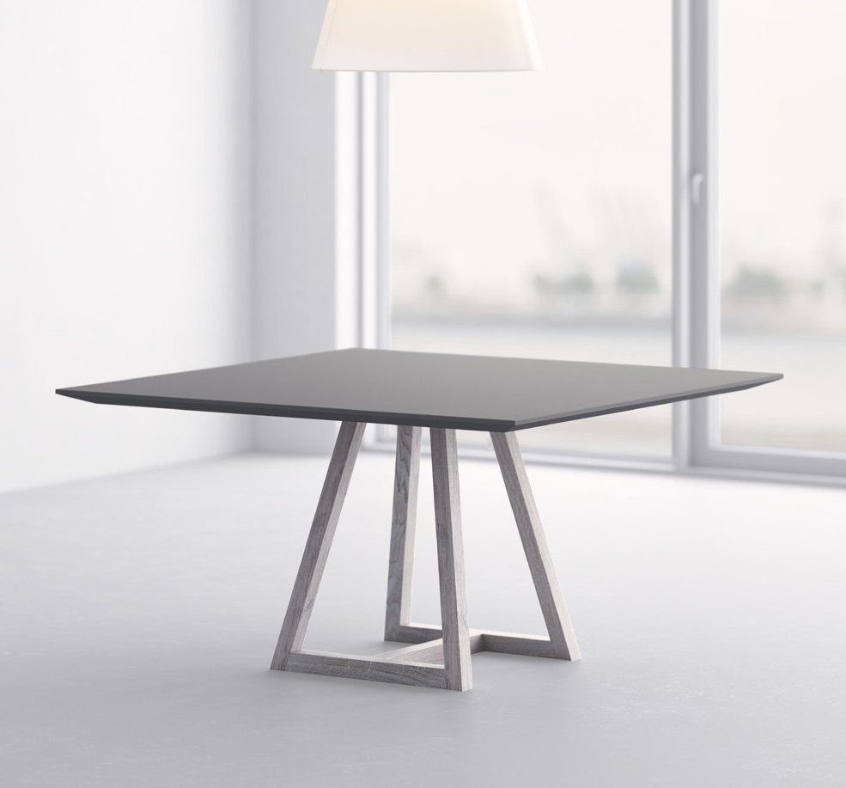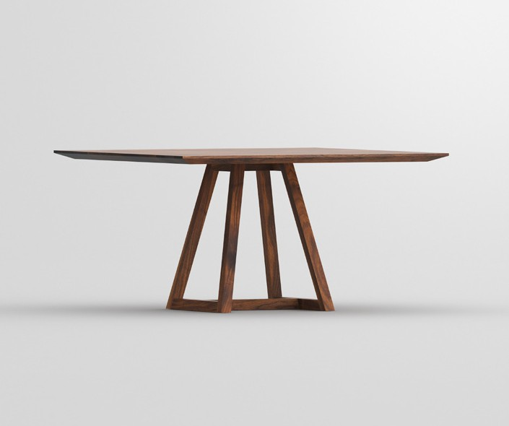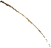

PRESS RELEASE

**Table MARGO SQUARE awarded for excellent design quality**

**with the Red Dot Award: Product Design 2019**

vitamin design receives the Red Dot Award: Product Design 2019 for

their Table MARGO SQUARE. The renowned jury awards only the pro- ducts with extraordinary design quality.

Table MARGO SQUARE - Elegance, Purity and architectural strength. At first glance, the graphi-

cal quality of the table‘s modern form appears. The structural elements are defined by clarity of line. The design elements have been refined with a clear, minimalistic square table top made. The choice between solid wood and linoleum enables marvellous combination possibilities. The edge profile is made by individual choice with a straight or chamfered edge, completing the graphical expression. Design: gg designart

The founde and CEO of Red Dot, Professor Dr. Peter Zec says:

“I would like to congratulate the laureates sincerely on their wonderful success. The fact that their products were able to satisfy the strict criteria of the jury bears testimony to their award- winning design quality. The laureates are thus setting key trends in the design industry and are showing where future directions may lead”.

The Red Dot Award: Product Design is one of the

world’s largest design competitions. In 2019, de- signers and manufacturers from 55 countries en- tered more than 5,500 products in the competiti- on. The international jury comprises experienced experts from different disciplines and has been convening for more than 60 years in order to se- lect the year’s best designs. During an adjudica- tion process that spans several days, they try out the products, discuss them and ultimately reach a well-founded decision regarding the design qua- lity of the entries. True to the motto “In search of good design and innovation”, their assessment focuses on criteria such as the level of innovation, functionality, formal quality, longevity and ergo- nomics.

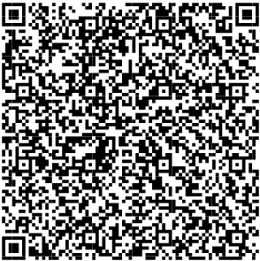

**VITA** - LIFE

**MIN** - MINIMALISM **VITAMIN** - HEALTH **DESIGN** - CREATION

vitamin design - nature friendly minimalistic design.

vitamin design was honored with the German Brand Award of the German Design Council

for outstanding brand management.

**About the Red Dot Design Award**

In order to appraise the wide scope of design in a professional manner, the Red Dot Design

Award is broken down into the three distinct disciplines: the Red Dot Award: Product De- sign, Red Dot Award: Brands & Communication Design and Red Dot Award: Design Concept. With more than 18,000 submissions, the Red Dot Award is one of the largest design com- petitions in the world. In 1955, a jury convened for the first time to assess the best designs of the day. The name and brand of the award were developed in the 1990s by Red Dot CEO, Professor Dr. Peter Zec. Since then, the sought-after Red Dot is the revered international seal of outstanding design quality. The winners are presented in yearbooks, museums and online. Further information: [www.red-dot.org.](http://www.red-dot.org/)

Press contact at Red Dot:

Julia Hesse

Manager PR & Communications Red Dot GmbH & Co. KG Gelsenkirchener Str. 181

45309 Essen, Germany Phone: +49 201 30104–58 [j.hesse@red-dot.de](mailto:j.hesse@red-dot.de) [www.red-dot.de/presse](http://www.red-dot.de/presse)

**About vitamin design**

vitamin design team designs and produces solid wood furniture with that certain so-

mething. gg designart, the company’s founder and designer, works very close with his team and has a long-standing experience and knowledge to develop a wide range of demanding solid wood furniture. Thanks to their up-to-date design the prospective classics from vitamin design are subtly presented based on ecological requirements and timeless modernity. Based on in-house and on close cooperation with selected manufacturers, vitamin design ensures

his high performance and quality standards. Therefore the focus lies on flexibility, clear design

and enhanced functionalities.

Press contact:

Gintaras Grabliauskas Dona Handelsges. mbH Grosse Elbstrasse 40

22767 Hamburg, Germany Phone: +49 (40) 31798362 [info@vitamin-design.com](mailto:info@vitamin-design.com) [www.vitamin-design.com/press](http://www.vitamin-design.com/press)

[www.vitamin-design.com](http://www.vitamin-design.com/)