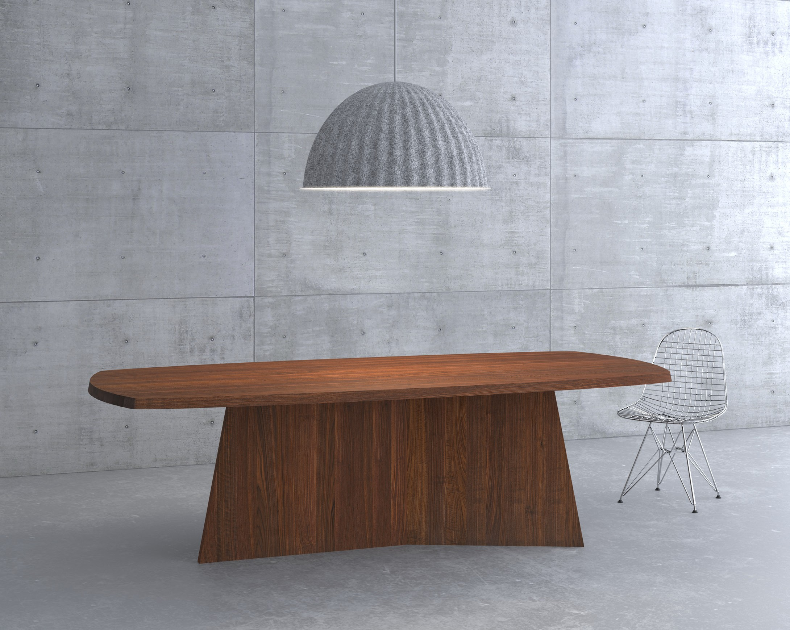

PRESS RELEASE

**Table LOTUS**

**Pure elegance, purity and architectural strength.**

The authentic look gives the table LOTUS a strong expression – ideal for modern

living spaces. The prominent frame and the extraordinary sloping table top are cha- racteristic features, giving the table lightness at the same time robustness with high recognition value.

Table LOTUS assured the German Design Council of its unique design and received the GERMAN

DESIGN AWARD 2019 »Special Mention« in the category »Excellent Product Design« The jury stated: The large wooden foot provides a stable base and gives the table weight, as well as creating a visual presence which is further enhanced by the distinctive Y-shape.

Available in all solid wood types from vitamin design collection: European oak and knotted oak,

ash, beech, core beech, American maple, walnut and cherry wood, treated with herbal oil.

Design: gg designart

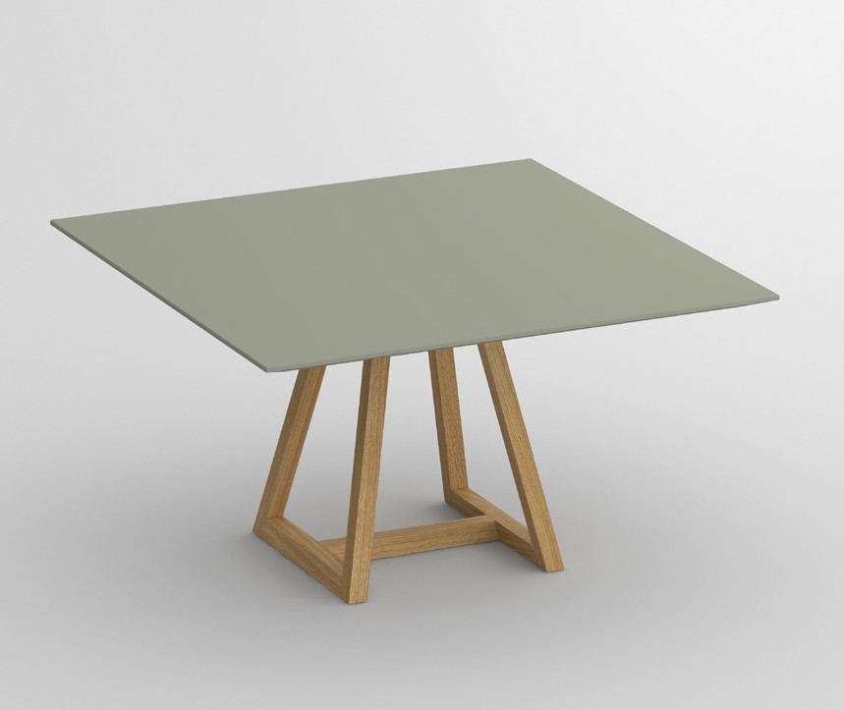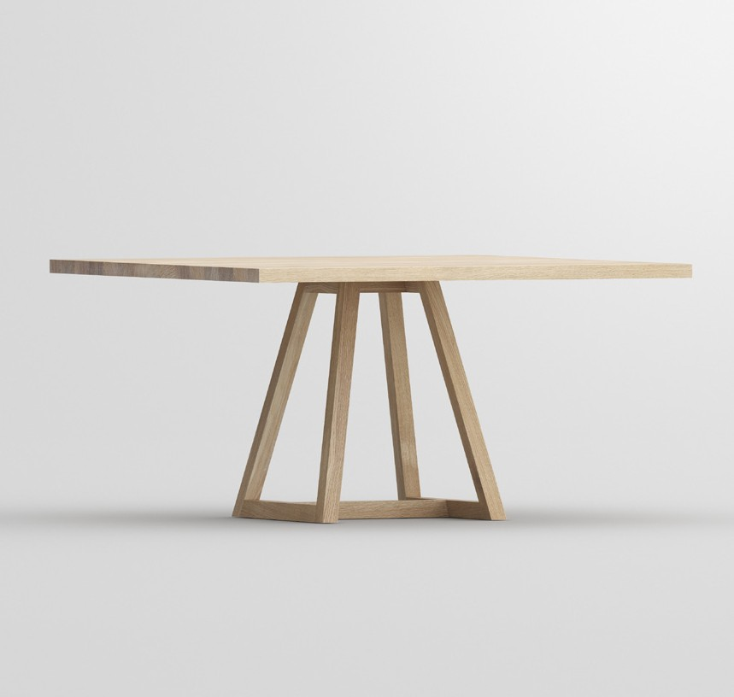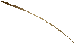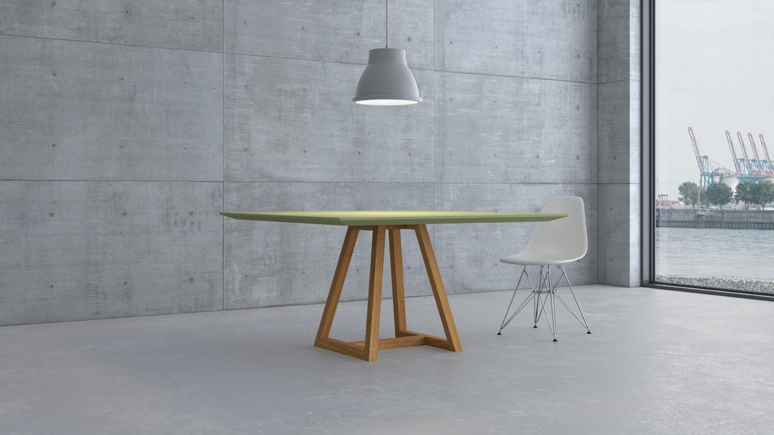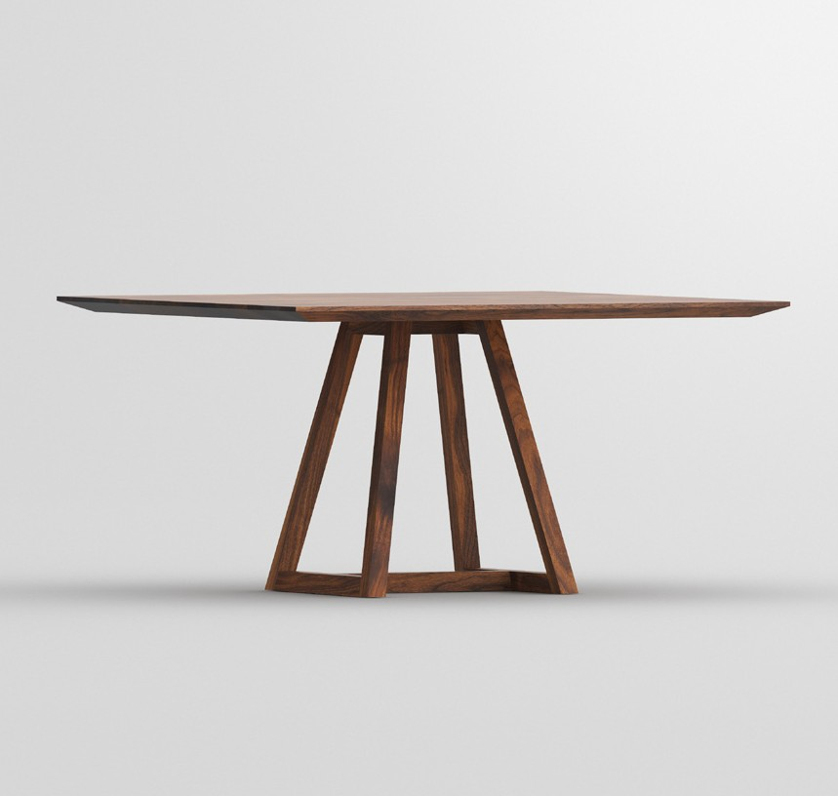

PRESS RELEASE

**Table MARGO SQUARE LINO**

**Practical symbioses between solid wood and linoleum**

The evolution of the multiple award-winning table MARGO iF Design

Award, ICONIC AWARDS 2017 und German Design

Award 2017.

At first glance the graphic quality of the table‘s mo-

dern form appears. The structural elements are defi- ned by clarity of line. The diverse design possibilities give a freedom choice in combining solid wood with linoleum. The edge profile can be chosen between straight or slanted edge. Whether subtle or prominent design everything is possible completing the graphical expression.

The trend barometer of the interior design industry

ICONIC AWARDS: Innovative Interior honoured the table MARGO SQUARE LINO with the award “selection” in the category “interior”. The combination possibility creates individual design freedom for architects and property developers. The German Design Council saw as well the distinctive features and nominated the tab- le for the German Innovation Award 2019. The innova- tion lies in the details with sustainable effect with the interplay of natural materials and craftsmanship.

Available in all linoleum and solid wood types from

vitamin design collection: European oak and knotted oak, ash, beech, core beech, American maple, walnut and cherry wood, treated with herbal oil.

Design: gg designart

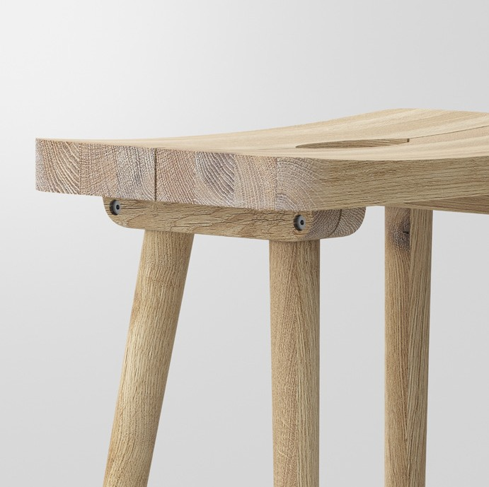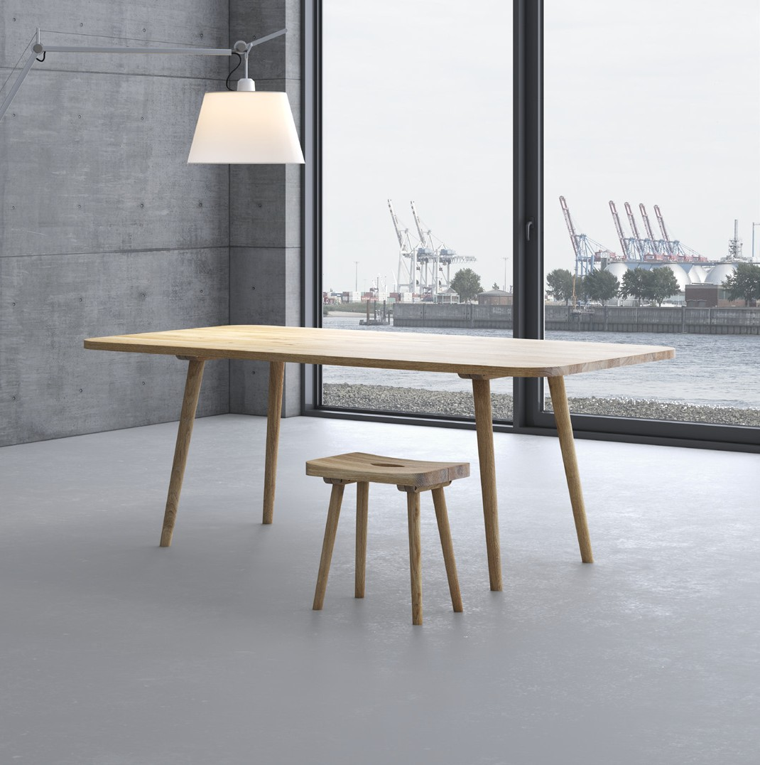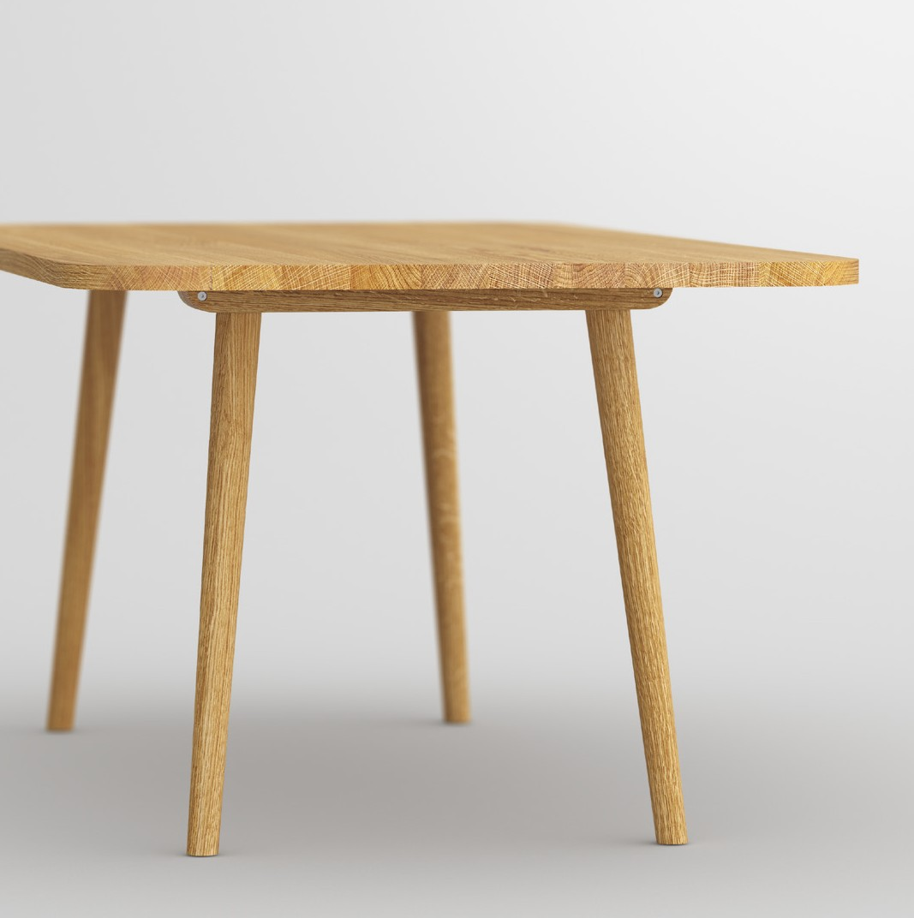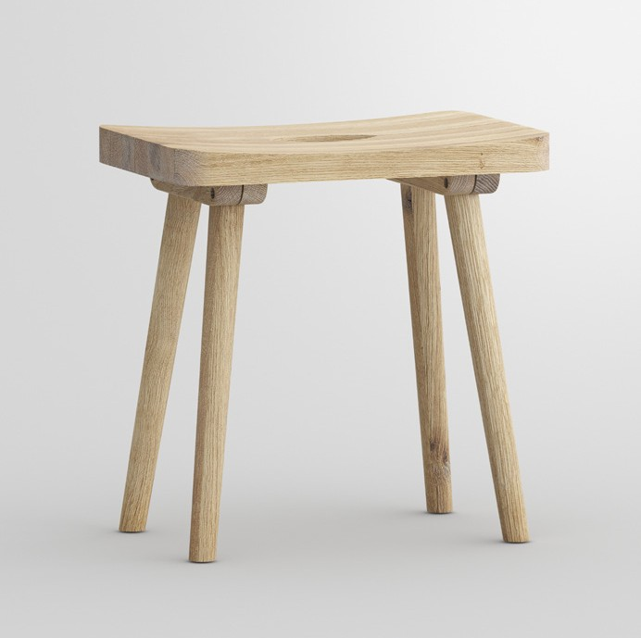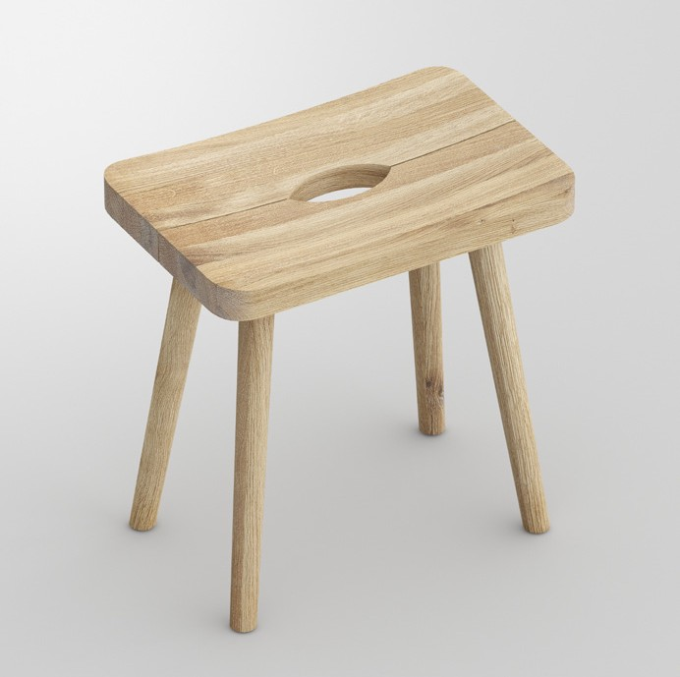

PRESS RELEASE

**UNA**

**Antiquity, modern interpreted with craftsmanship**

The canny joint of the legs with the table frame serves as a striking design feature. The

table and the stool appear distinctively interesting and exclusive by adding the ergonomic- al shape. Since the ancient times the stool is basic equipment in houses. Makes everywhe- re a great impression as a practical accessory at home. Sometimes in the kitchen some- times in the wardrobe with the grip opening the stool can be carried quickly and easily. Functional furniture with charm. The natural grain of the wood enhances the easy going character for a perfect homely feeling.

Available in all solid wood types from vitamin design collection: European oak and knotted oak, ash, beech, core beech, American maple, walnut and cherry wood, treated with her- bal oil.

Design: gg designart



**GERMAN BRAND AWARD WINNER**

**VITA** - LIFE

**MIN** - MINIMALISM **VITAMIN** - HEALTH **DESIGN** - CREATION

vitamin design - nature friendly minimalistic design.

vitamin design was honored with the German Brand Award of the German Design Council

for outstanding brand management.

**Digital network with vitamin design**

The restructuring of all business units into digital processes is for

every company an important topic with a huge potential. We of- fer a solution to implement individual content management with innovation, functionality and data integration. The consumer has the liberty to get the desired information at anytime and any- where. All products and information are just a click away.

**About vitamin design**

vitamin design team designs and produces solid wood furniture with that certain

something. G. Grabliauskas, the company’s founder and designer, works very close with his team and has a long-standing experience and knowledge to develop a wide range

of demanding solid wood furniture. Thanks to their up-to-date design the prospective classics from vitamin design are subtly presented based on ecological requirements and timeless modernity. Based on in-house and on close cooperation with selected manufac- turers, vitamin design ensures his high performance and quality standards. Therefore the focus lies on flexibility, clear design and enhanced functionalities.

Press releases:

[www.vitamin-design.com/press](http://www.vitamin-design.com/press)

Press contact:

Gintaras Grabliauskas Dona Handelsges. mbH Grosse Elbstrasse 40

22767 Hamburg

Germany

+49 (40) 31798362

[info@vitamin-design.com](mailto:info@vitamin-design.com)

[www.vitamin-design.com](http://www.vitamin-design.com/)